Customer Churn Prediction
Week 3 Report: Machine Learning Model Development
NexAfrica Machine Learning Internship
Prepared by: GLORIA BOATENG

1. Overview
This report covers Week 3 of the Customer Churn Prediction project: preparing training and testing data from the Week 2 feature-engineered dataset, building a baseline classification model, training two additional models, and comparing their performance to make an initial model selection.

2. Training and Testing Data
The feature-engineered and preprocessed dataset from Week 2 (7,043 rows x 36 feature columns) was split using an 80/20 stratified train/test split to preserve the churn class ratio (73.46% No / 26.54% Yes) in both sets.
Set | Rows | Columns
Training (X_train) | 5,634 | 36
Testing (X_test) | 1,409 | 36

3. Baseline Model - Logistic Regression
Logistic Regression was trained as the baseline classifier due to its simplicity and interpretability.
Metric | Score
Accuracy | 0.7999
Precision | 0.6554
Recall | 0.5187
F1-Score | 0.5791
ROC-AUC | 0.8425

Of 374 actual churners in the test set, the model correctly identified 194 (True Positives) but missed 180 (False Negatives), meaning roughly half of at-risk customers went undetected. 102 loyal customers were incorrectly flagged as churn risks (False Positives). The strong ROC-AUC of 0.8425 indicates good underlying ability to rank customers by risk, even though the default classification threshold leaves recall relatively low.

4. Additional Models

Decision Tree Classifier
Metric | Score
Accuracy | 0.7424
Precision | 0.5155
Recall | 0.4893
F1-Score | 0.5021
ROC-AUC | 0.6611

The Decision Tree performed the weakest of the three models across nearly every metric, including a notably low ROC-AUC of 0.661, only marginally better than random guessing. This is consistent with a single, pruned decision tree overfitting to noise in the training data rather than learning generalizable patterns.

Random Forest Classifier
Metric | Score
Accuracy | 0.7857
Precision | 0.6216
Recall | 0.4920
F1-Score | 0.5493
ROC-AUC | 0.8219

Random Forest improved substantially on the single Decision Tree, with a ROC-AUC of 0.822, close to Logistic Regression's 0.843, by averaging across many trees to reduce overfitting. However, it still trailed Logistic Regression on accuracy, precision, and F1-score at default (untuned) settings.
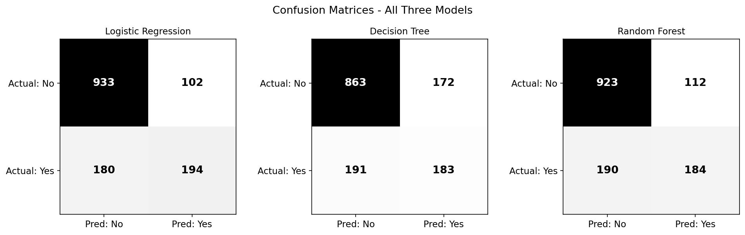
Figure 1: Confusion matrices for all three models

5. Model Comparison
Model | Accuracy | Precision | Recall | F1-Score | ROC-AUC
Logistic Regression | 0.7999 | 0.6554 | 0.5187 | 0.5791 | 0.8425
Decision Tree | 0.7424 | 0.5155 | 0.4893 | 0.5021 | 0.6611
Random Forest | 0.7857 | 0.6216 | 0.4920 | 0.5493 | 0.8219
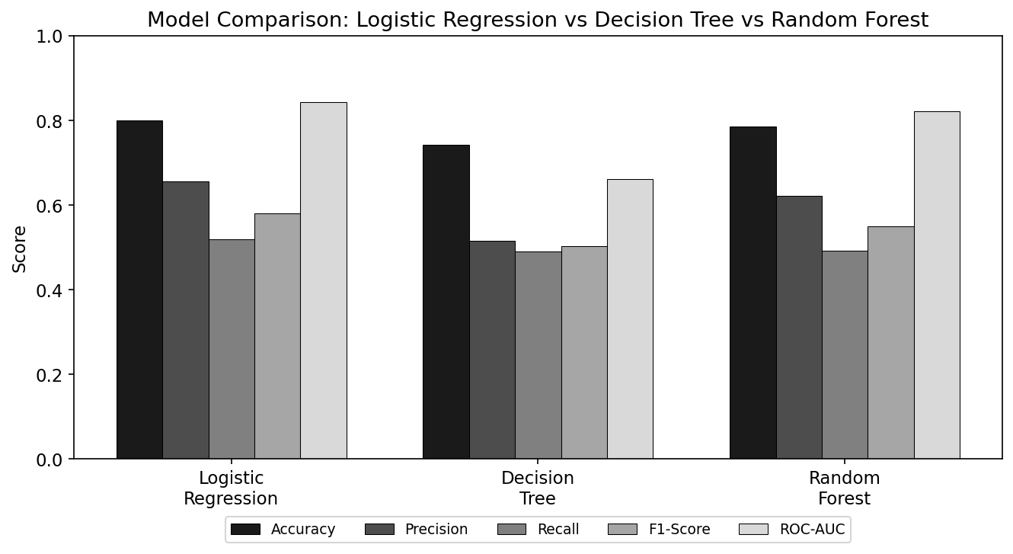
Figure 2: Model comparison across all five evaluation metrics
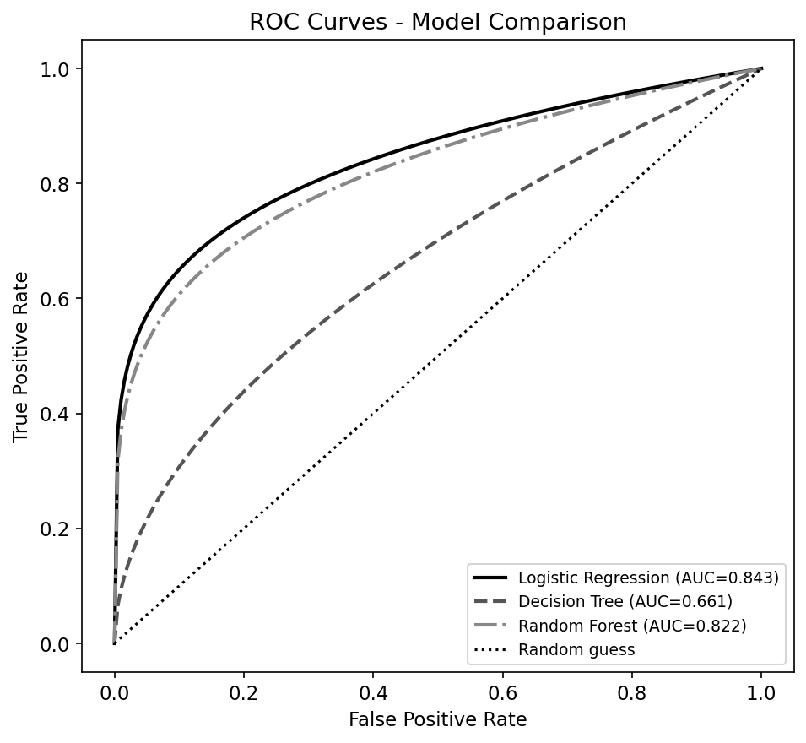
Figure 3: ROC curves for all three models

6. Initial Model Selection
Logistic Regression currently performs best across accuracy (79.99%), precision (65.54%), F1-score (0.579), and ROC-AUC (0.843), despite being the simplest of the three models tested, a useful reminder not to assume more complex models automatically outperform simpler ones. Random Forest is a close second on ROC-AUC (0.822) but trails on other metrics at default settings. Decision Tree performs weakest across the board, likely due to overfitting on the training data.
Recall remains a shared weakness across all three models (49-52%), meaning roughly half of actual churners go undetected regardless of model choice. Given the business cost of missing an at-risk customer (a lost customer) versus the cost of a false alarm (a wasted retention offer), improving recall on the churn class, without excessively sacrificing precision, is the primary target for Week 4. Logistic Regression's strong ROC-AUC of 0.843 suggests the underlying model already discriminates well between classes; the main opportunity lies in addressing class imbalance (via class weighting or resampling) and tuning the decision threshold or hyperparameters, rather than needing a fundamentally different modeling approach.
Preliminary selection: Logistic Regression, to be re-evaluated after imbalance handling and hyperparameter tuning in Week 4.

